13.Demonstrate Infrastructure as a Service (IaaS) by creating a Virtual Machine using a Public Cloud Service Provider (Azure), configure with required memory and CPU

AT FIRST YOU NEED TO CREATE AN ACCOUNT OF MICROSOFT AZURE….

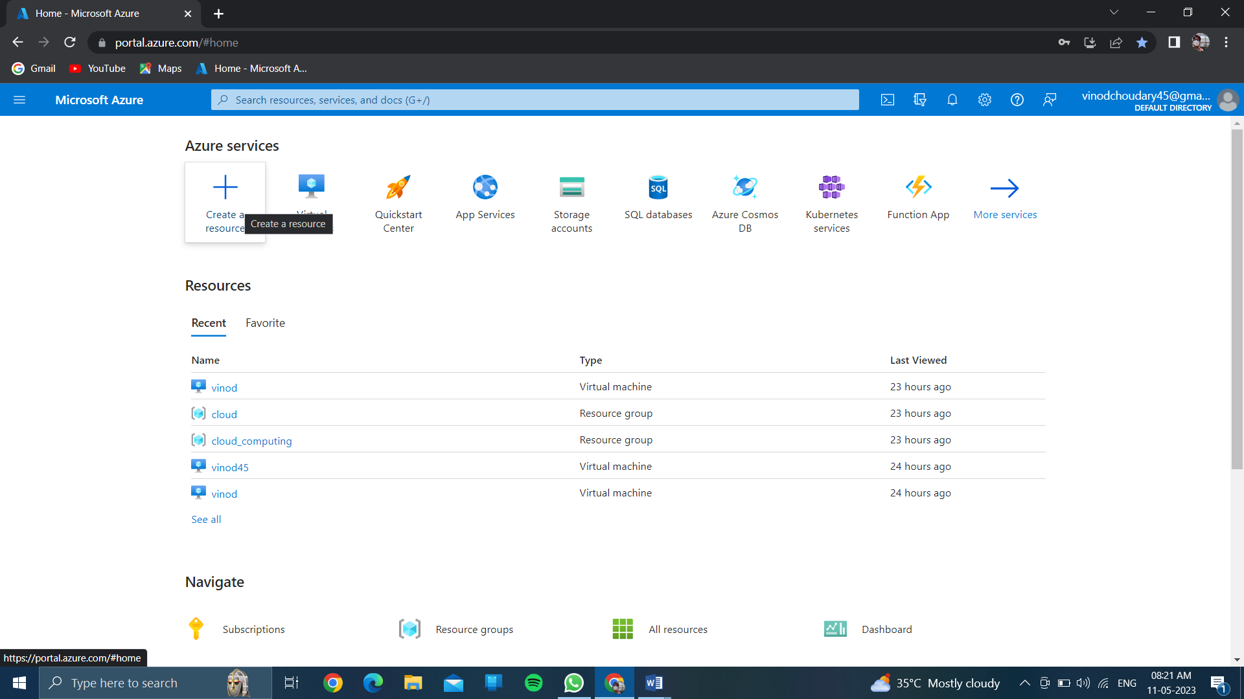

CLICK ON CREATE A RESOURCE…..

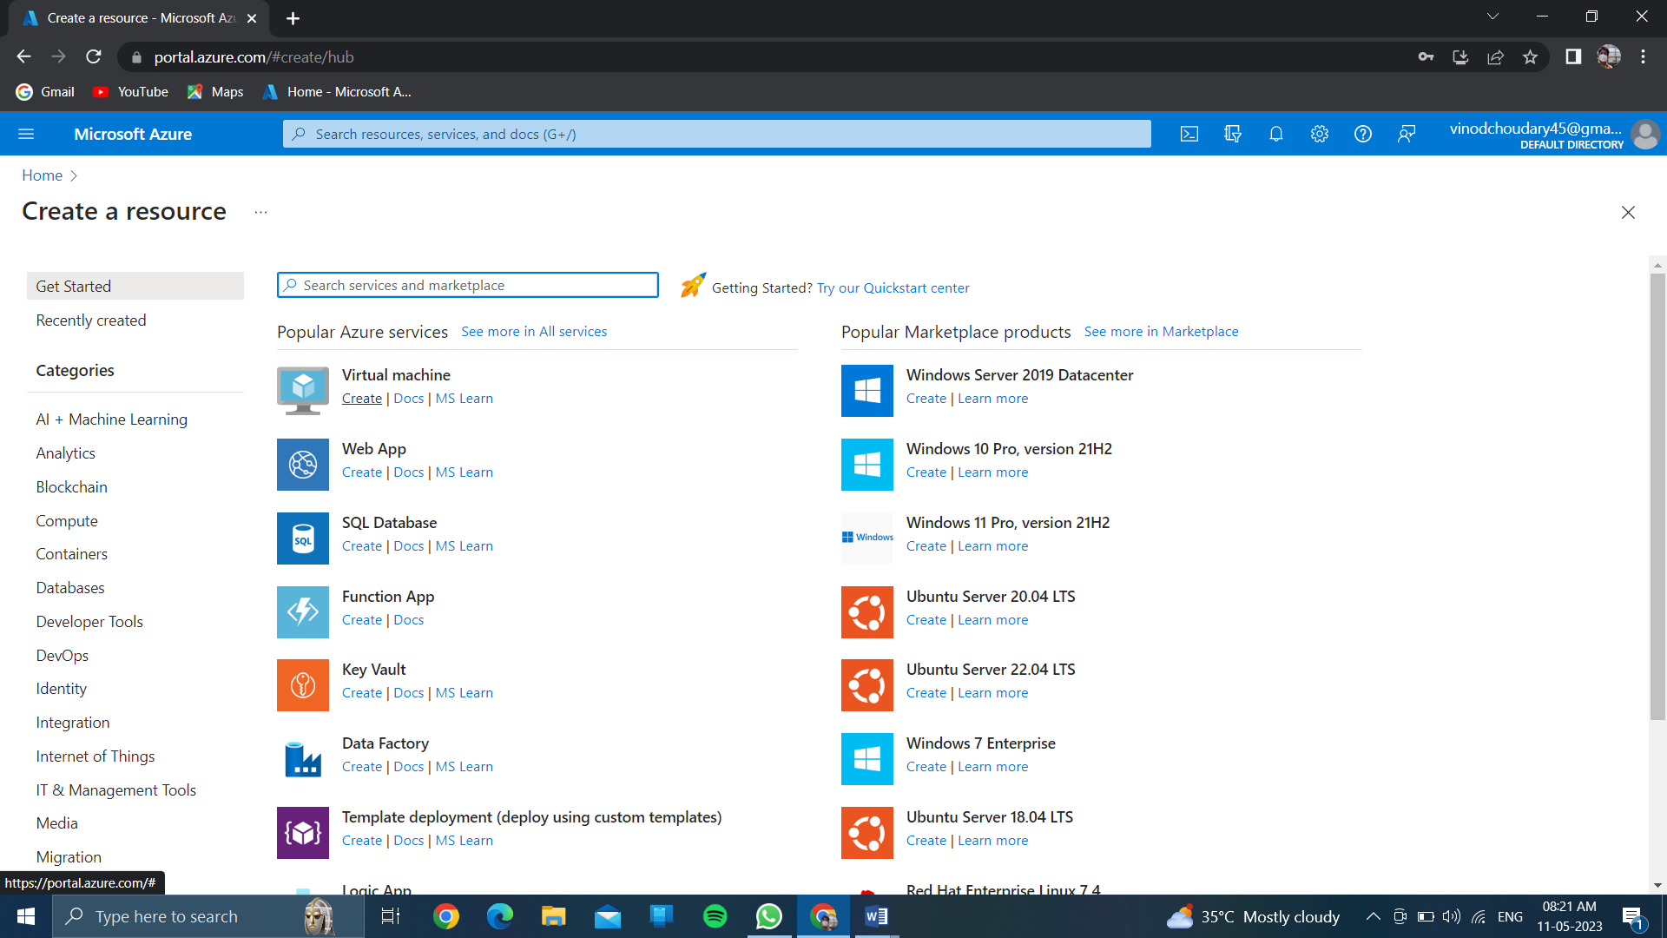

CLICK ON CREATE OF VIRTUAL MACHINE….

CREATE A RESOURCE GROUP…..

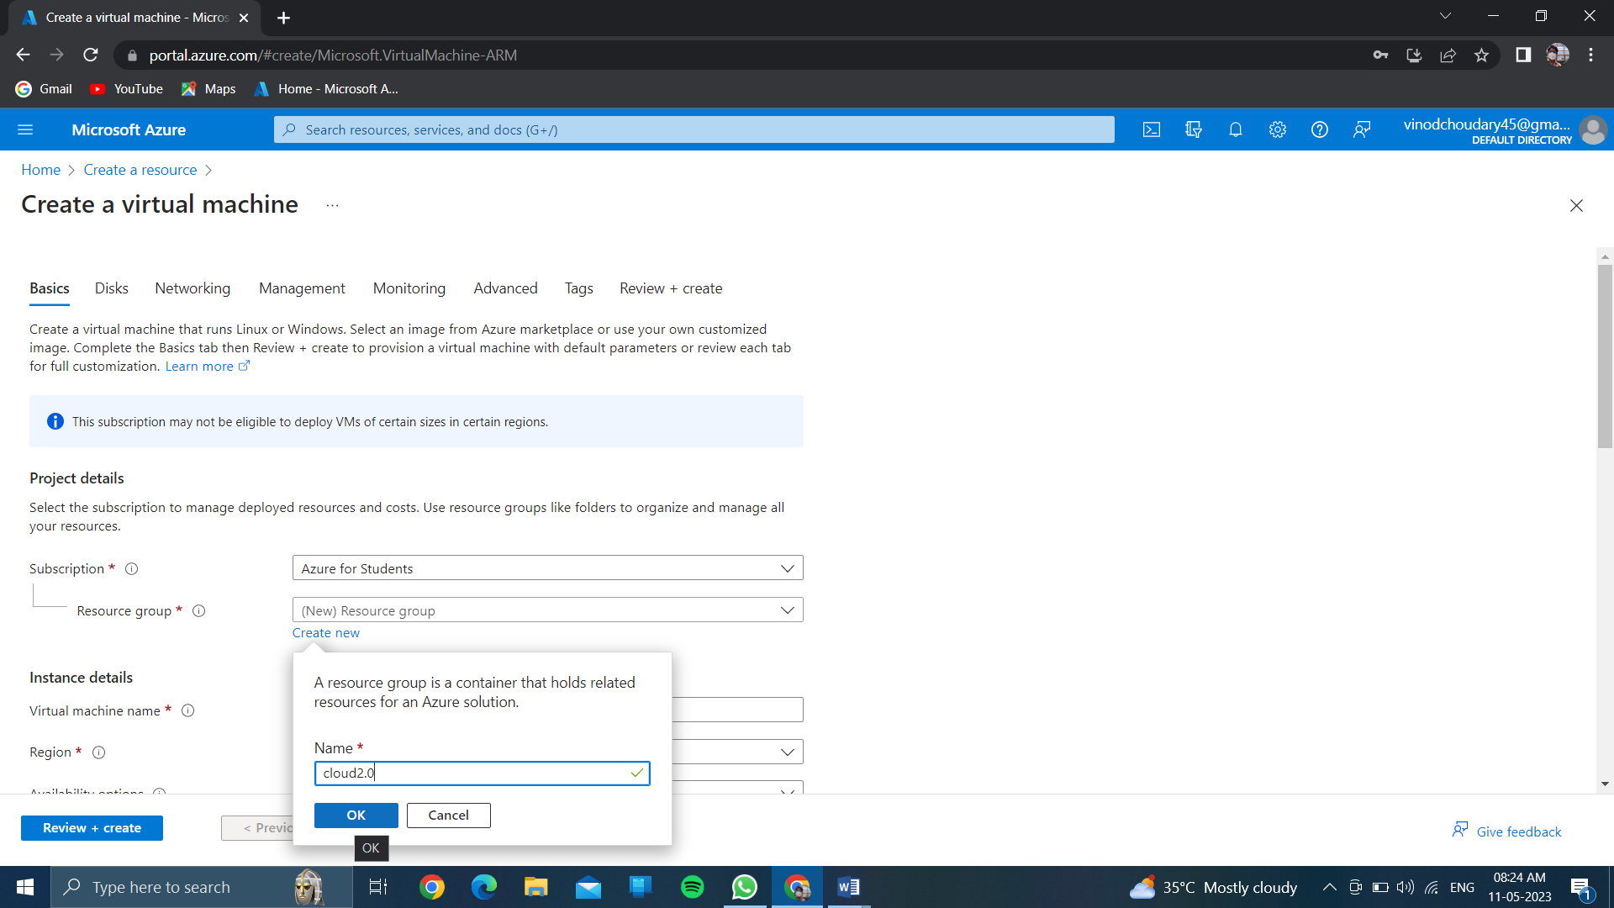

Give the name of virtual machine….

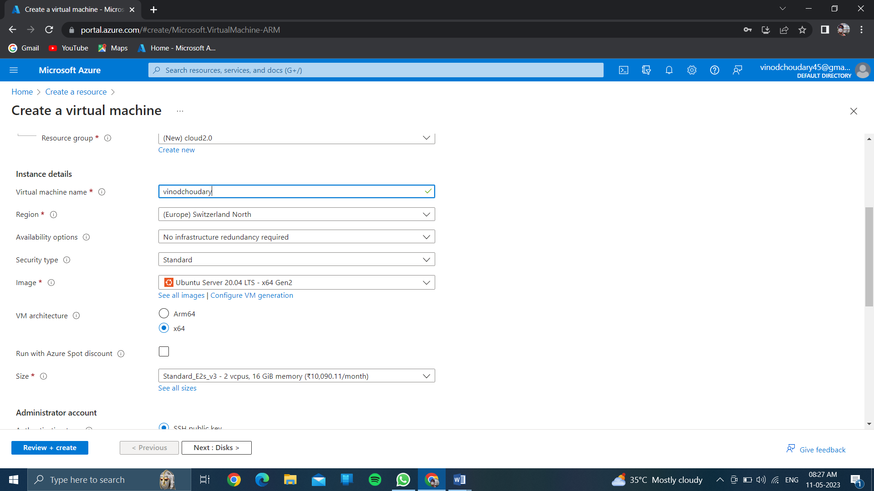

Choose any region………based on cpu & ram configuration of size….

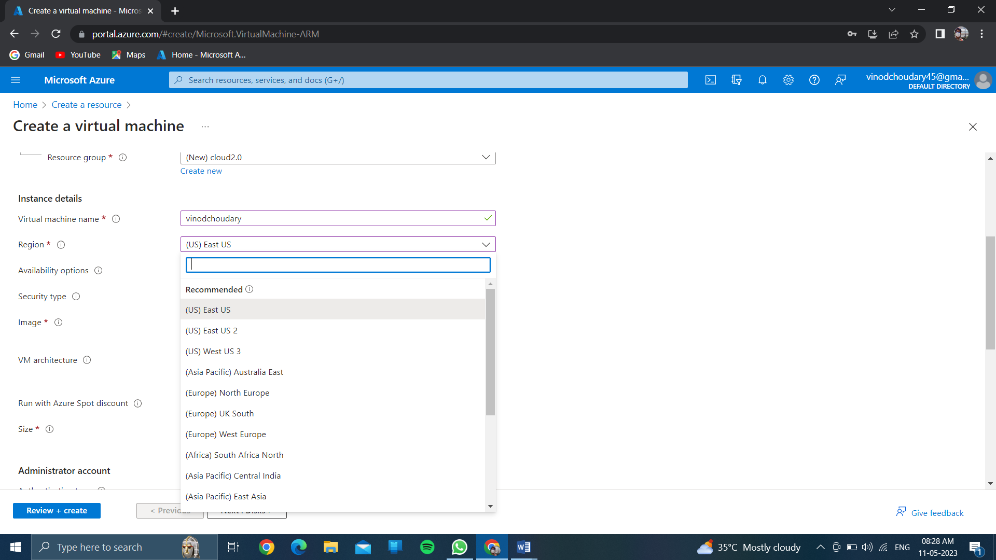

Click on authenticated type //and choose >>password<<

And create your own username and password…..

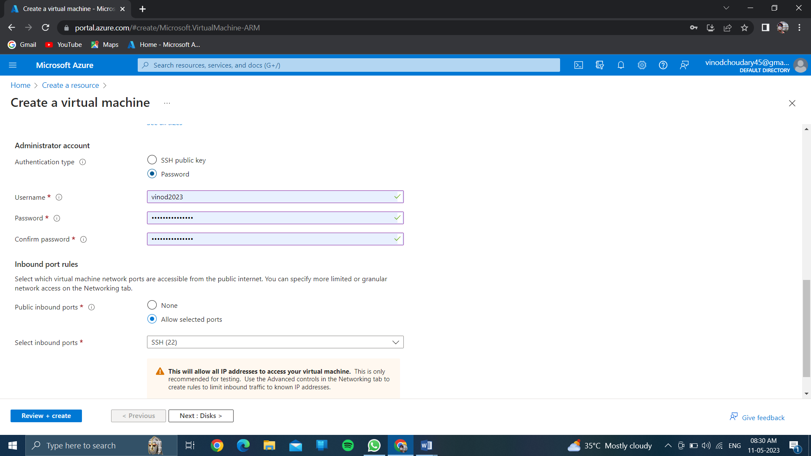

Click on<<review and create>>

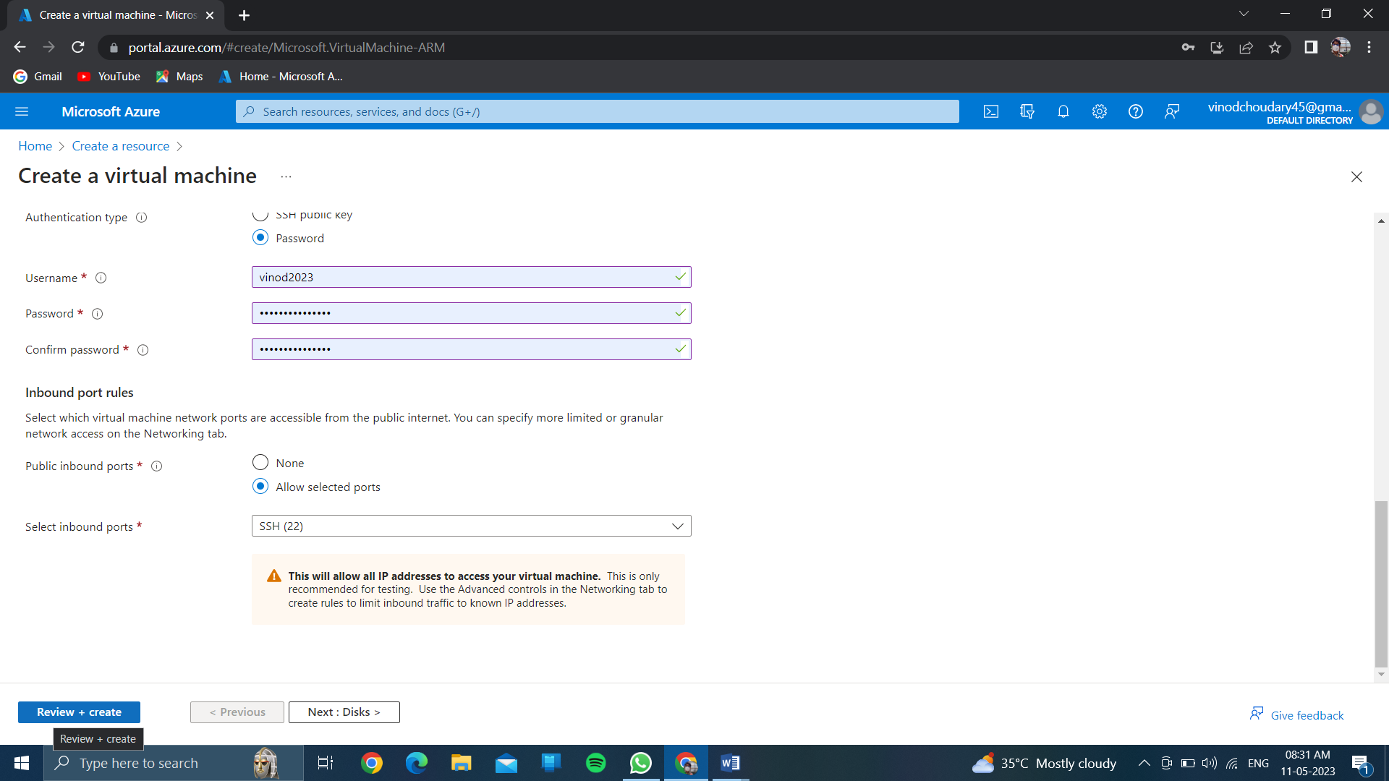

And wait few minutes for getting the validation passed…..

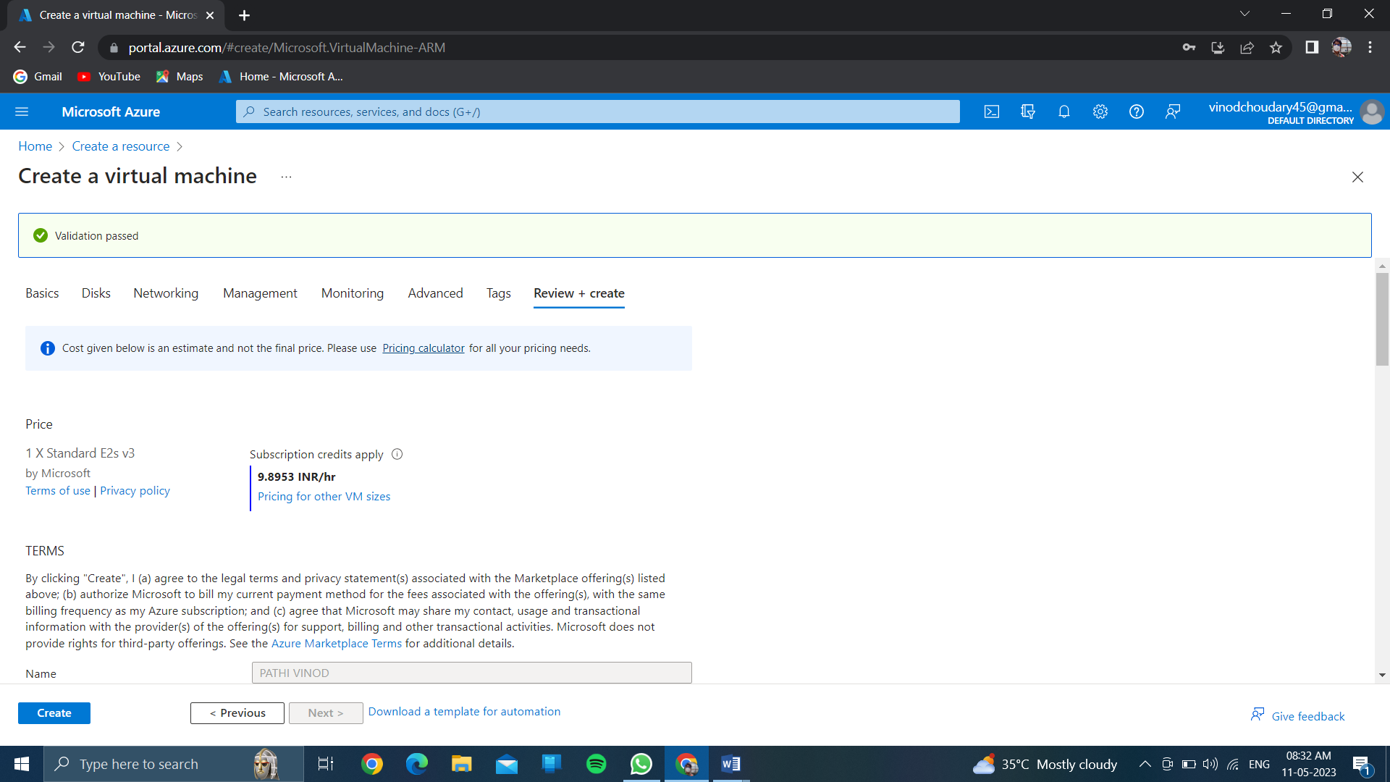

Click on create…..

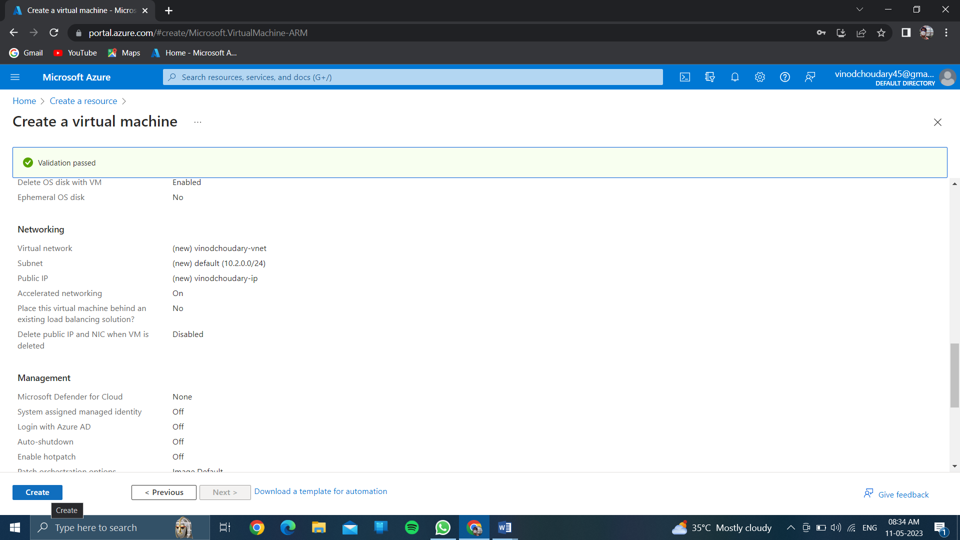

And wait for few minutes for complitation of deployment process>>

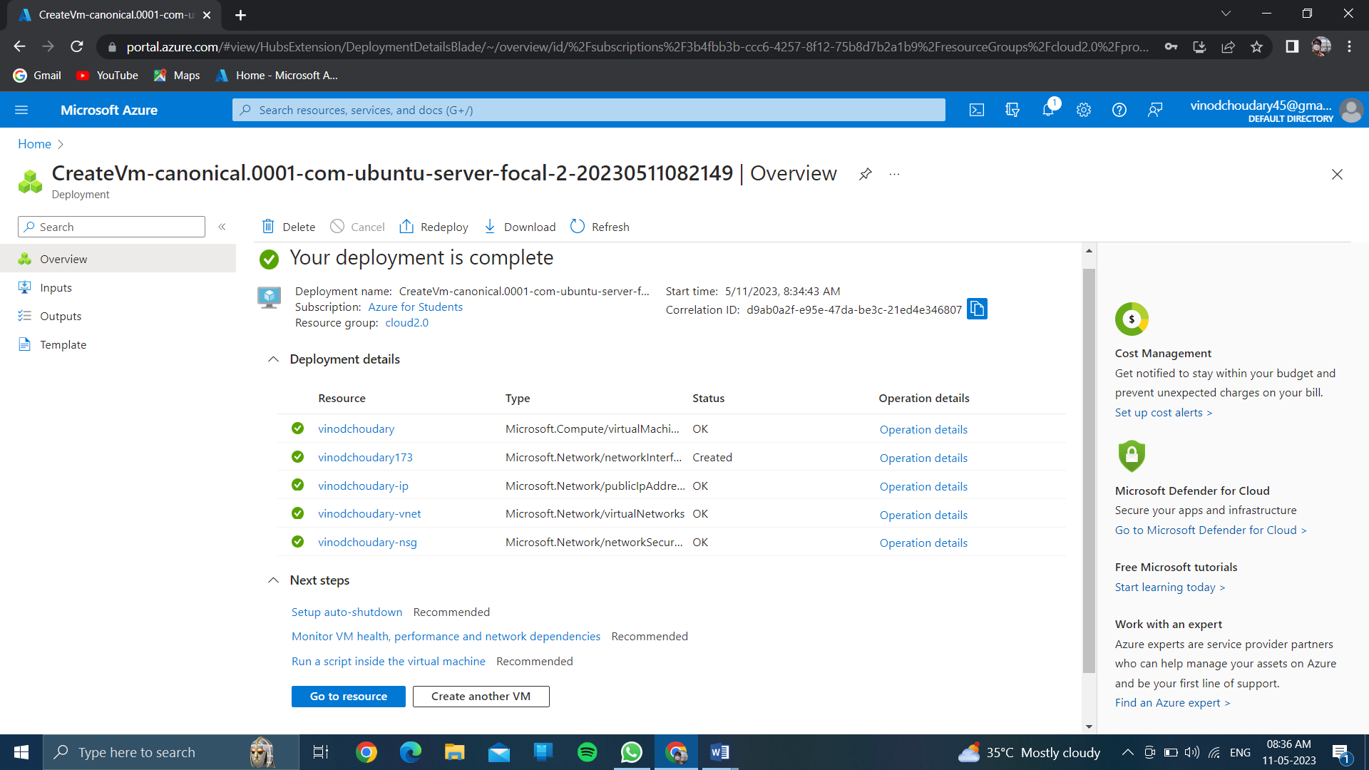Then after click on <<resource>>….

Then after click on <<create>>then see your resource group is created and virtual machine also…..

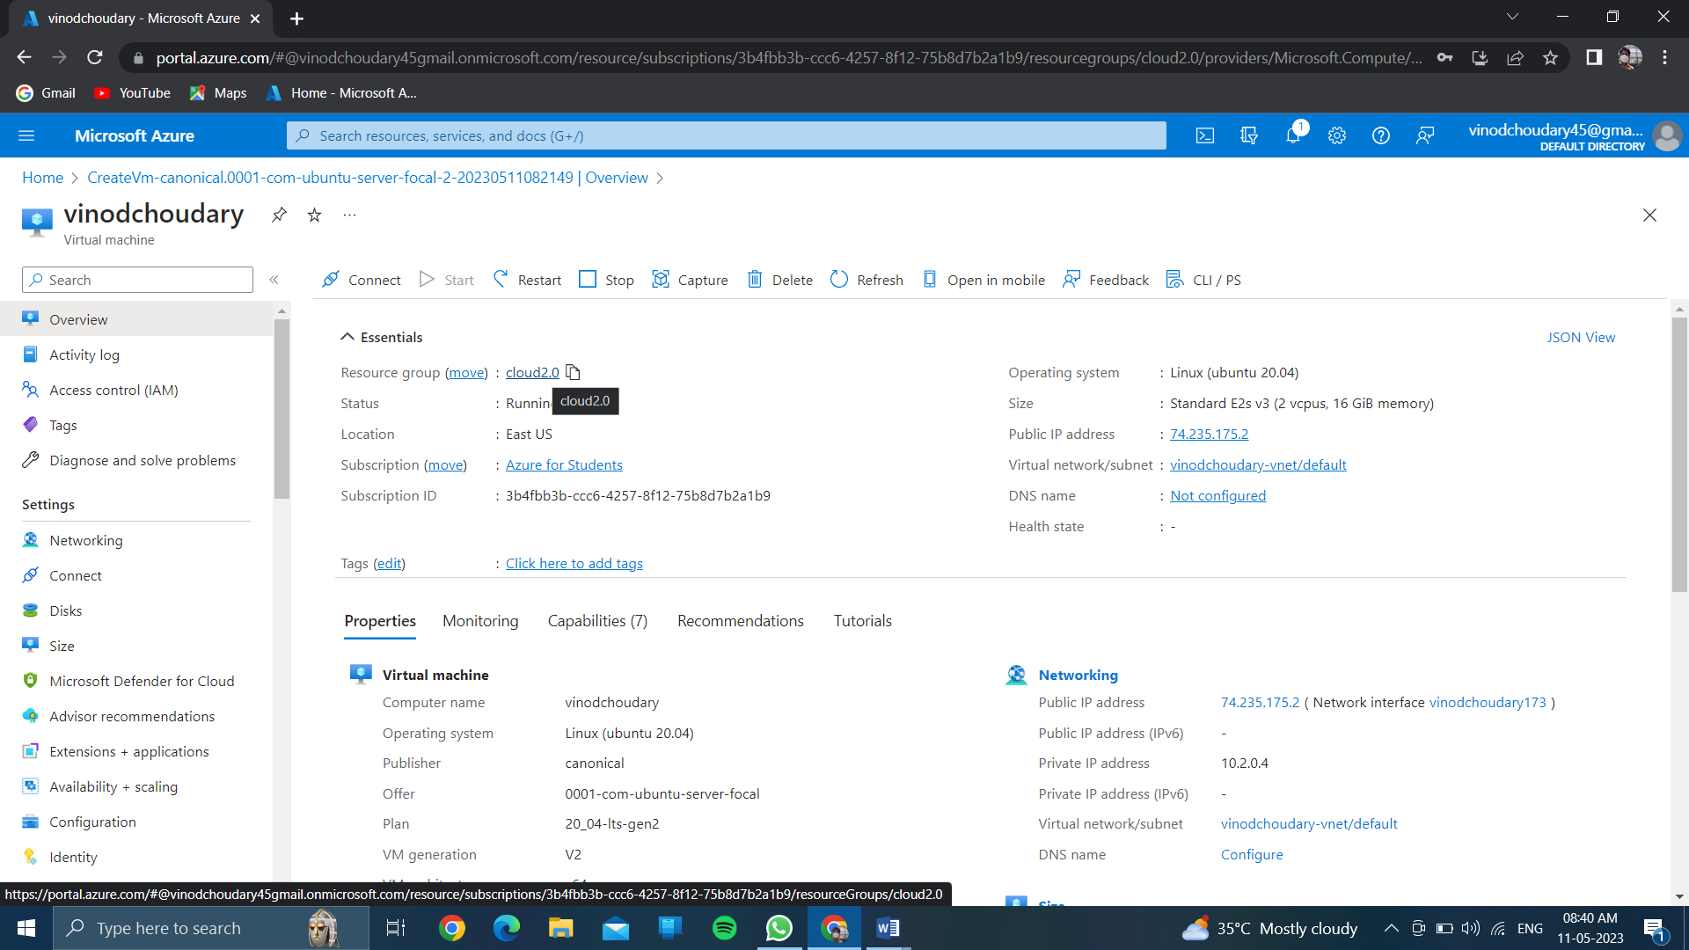

And click on << back to home >>

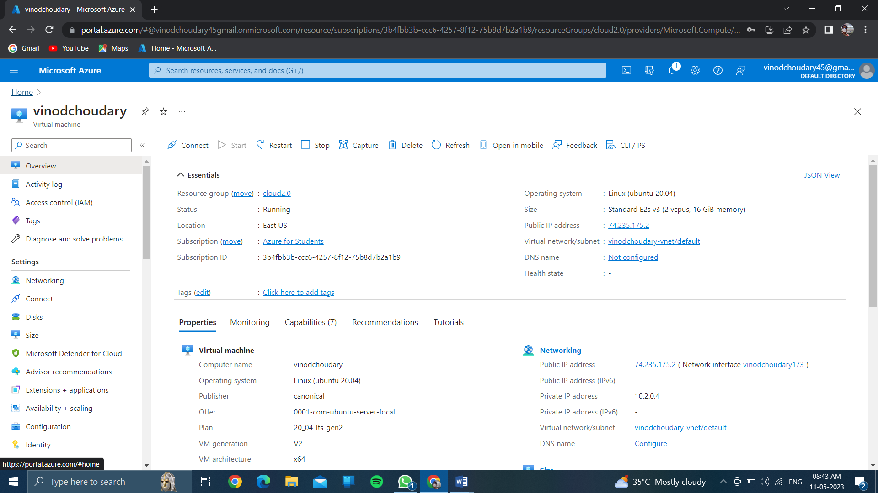

Now see your virtual machine is created….

